**EXP 1: Create a simple cloud software application and provide it as a service using any Cloud Service Provider to demonstrate Software as a Service (SaaS).**

**DATE:13-02-25**

**AIM**:  The aim is to develop a simple, cloud-based application and demonstrate the principles of SaaS by providing access to the software via the cloud, making it scalable, cost-effective, and easily accessible for users.

**PROCEDURE:**

**STEP1:**GO TO ZOHOCREATOR.COM AND LOGIN TO YOUR ACCOUNT

**STEP2:**CLICK CREATE NEW APPLICATION AND CREATE FROM SCRATCH

**STEP3:** ENTER APPLICATION NAME AND CREATE APPLICATION

**STEP4:**CLICK ON CREATE NEW FORM AND NAME THE FORM

**STEP5:**ENTER THE DETAILS

**STEP6:**THE SOFTWARE HAS BEEN CREATED.

**STEP1:**GO TO ZOHOCREATOR.COM AND LOGIN TO YOUR ACCOUNT

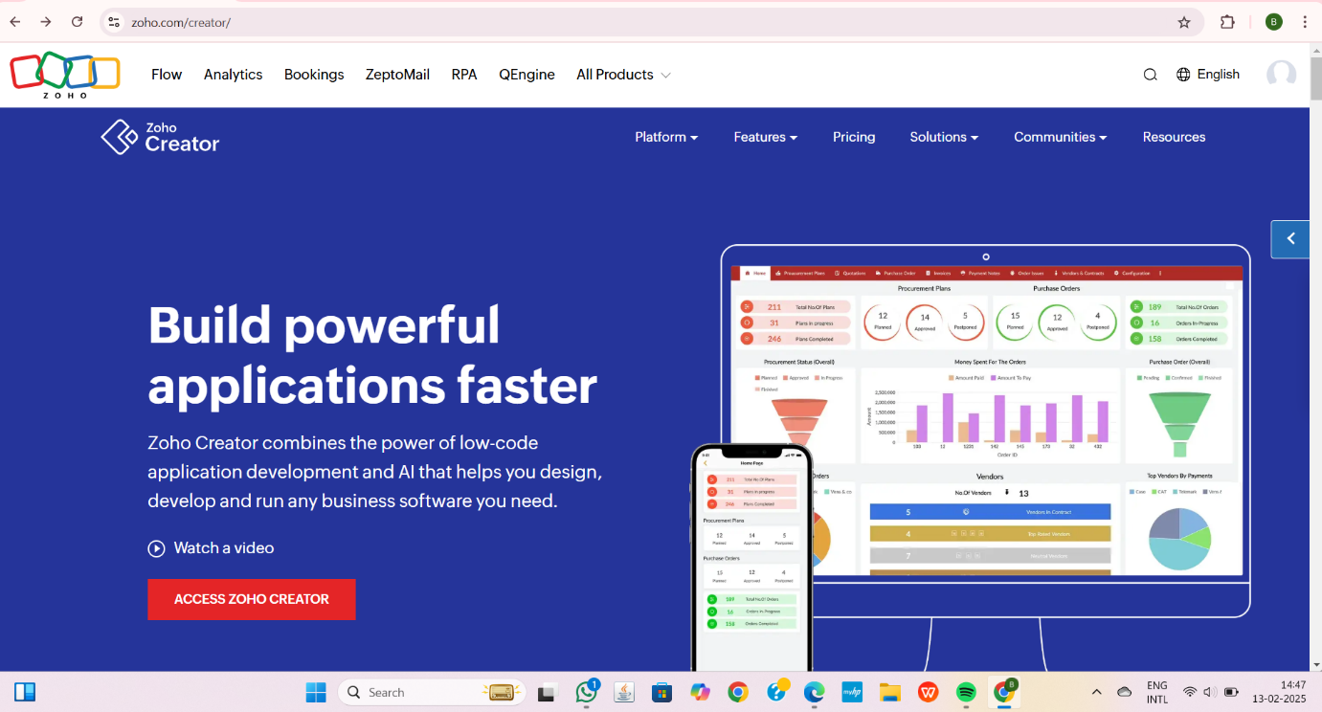

**STEP2:**CLICK CREATE NEW APPLICATION AND CREATE FROM SCRATCH

**STEP3:** ENTER APPLICATION NAME AND CREATE APPLICATION

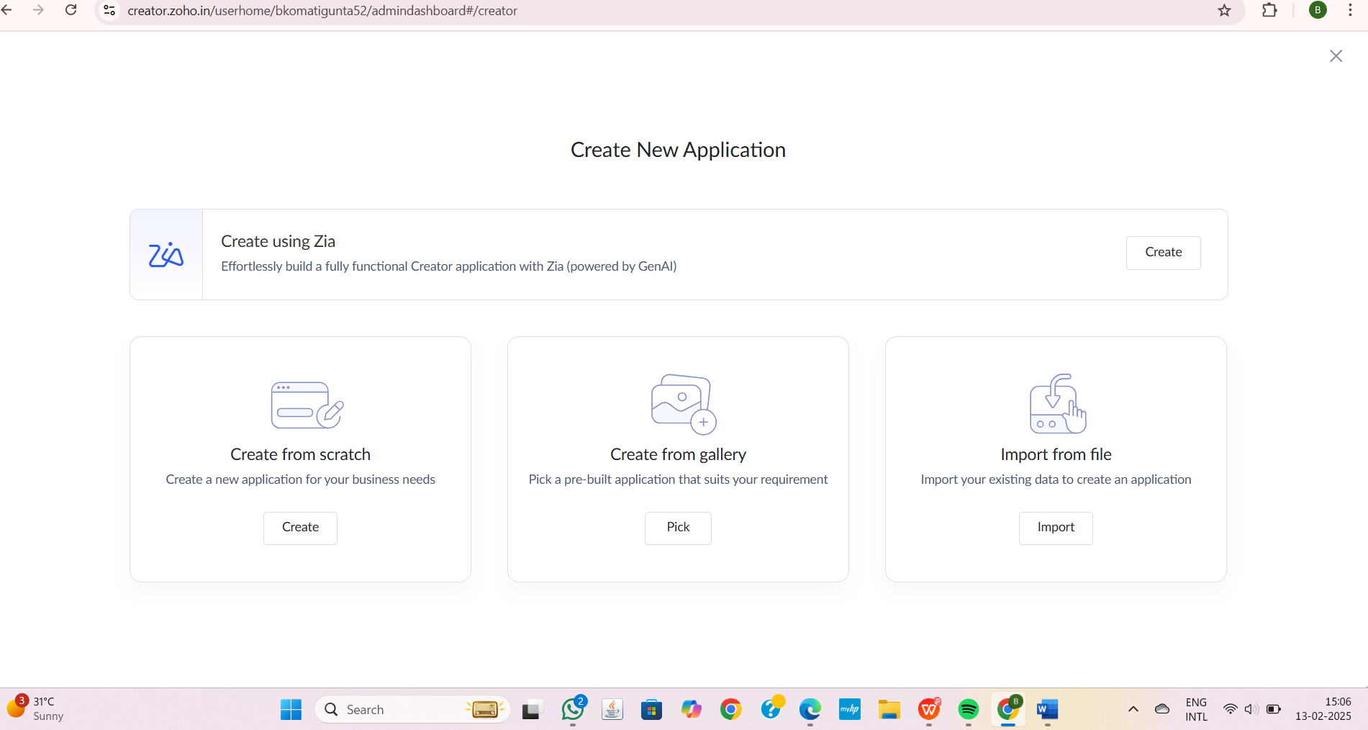

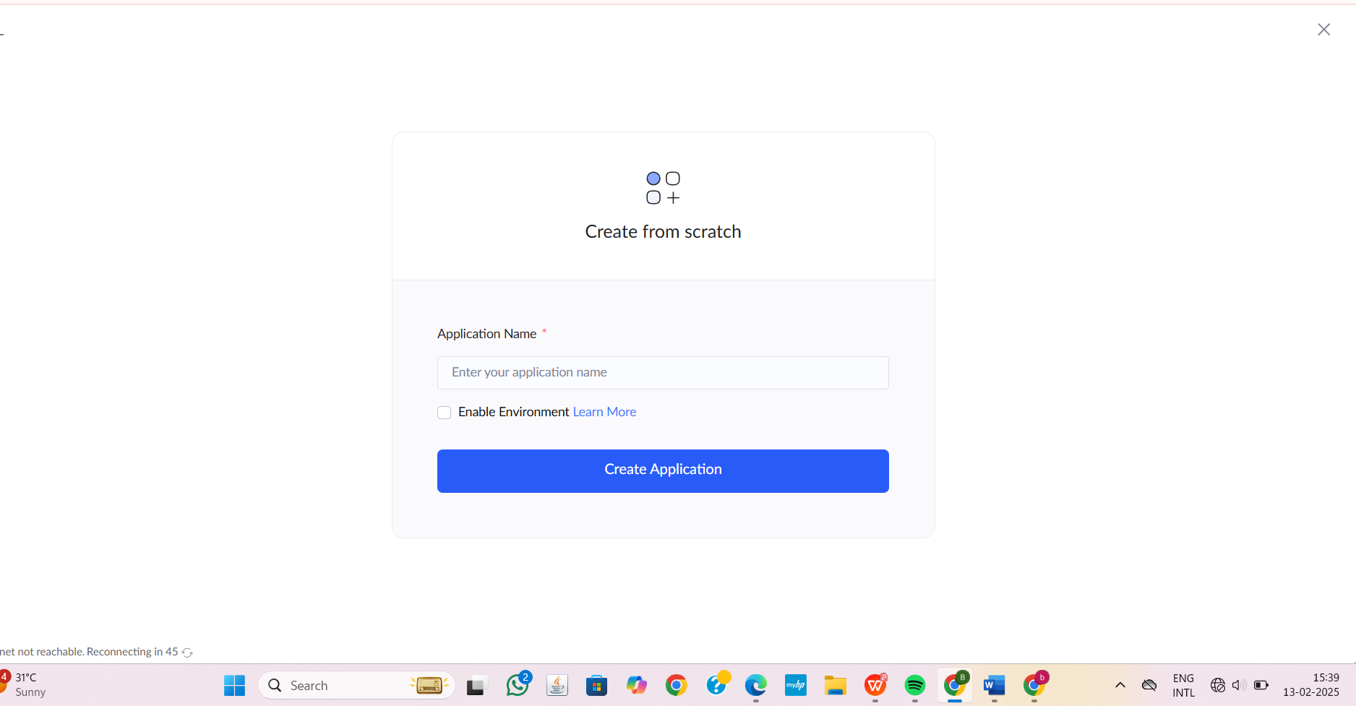

**STEP4:**CLICK ON CREATE NEW FORM AND NAME THE FORM

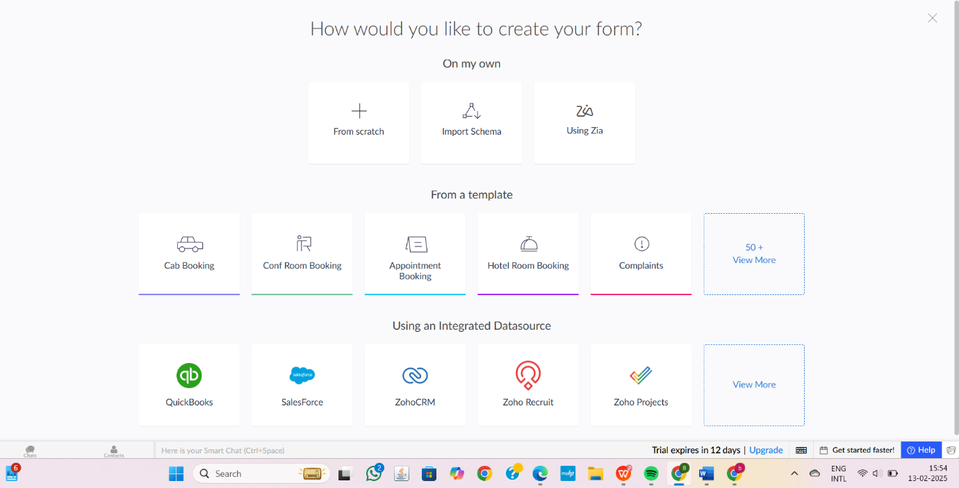

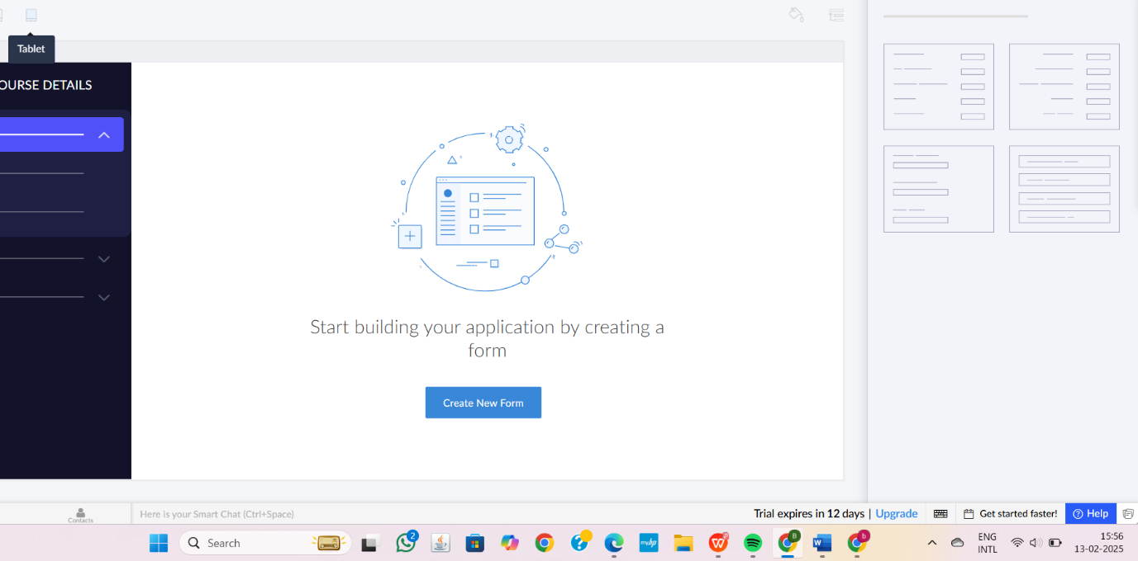

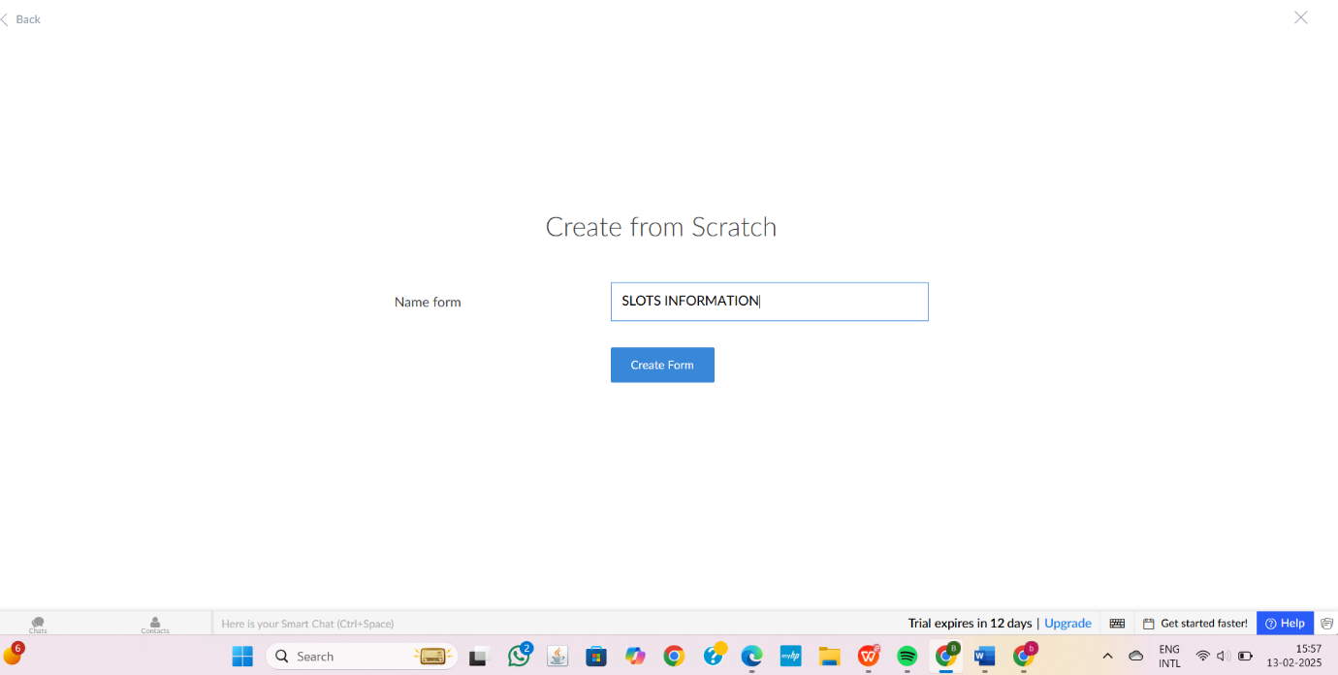

1.SLOTS INFORMATION AND ITS DETAILS

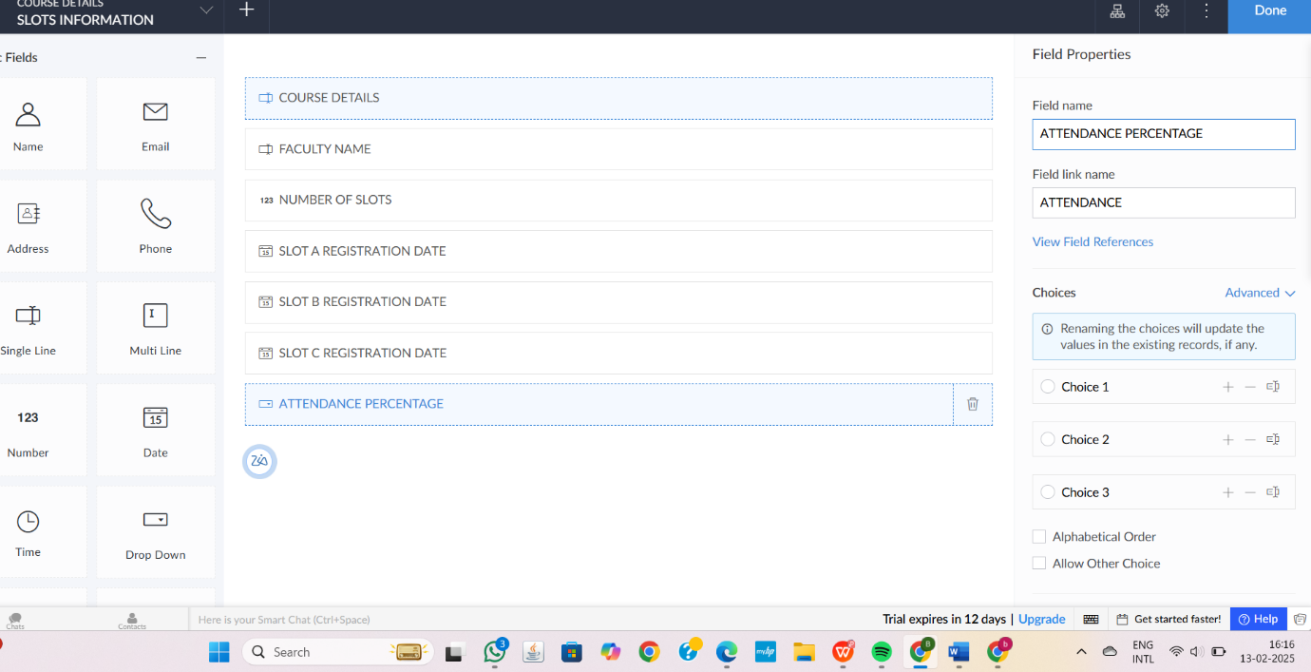

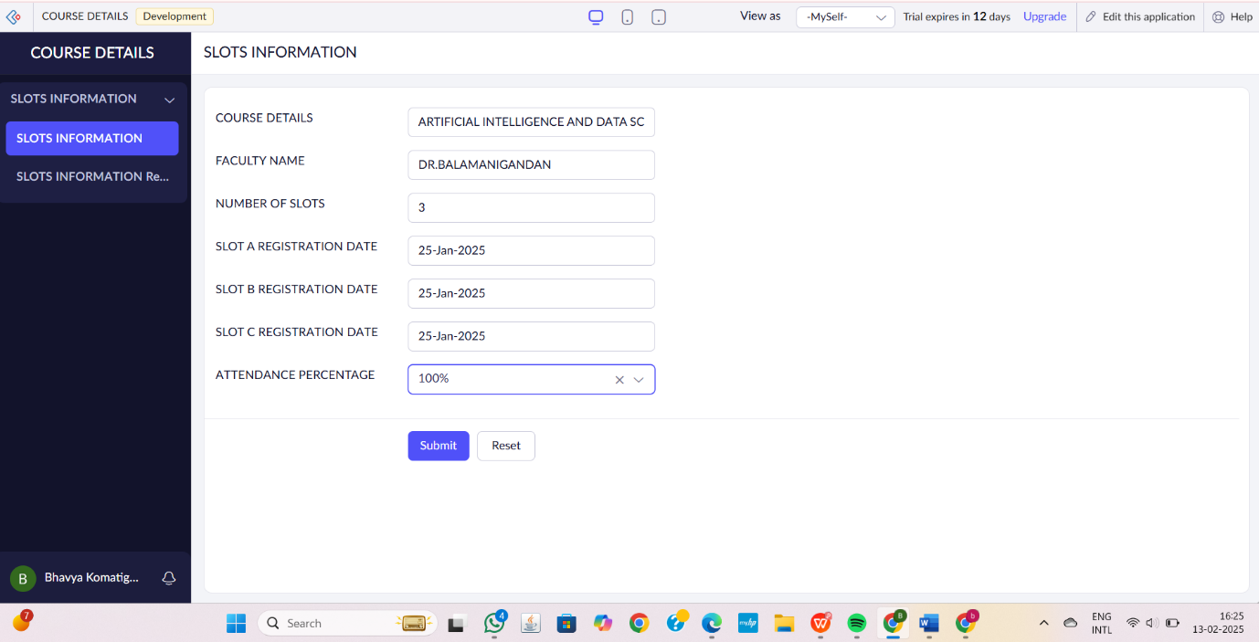

2.FACULTY INFORMATION AND ITS DETAILS

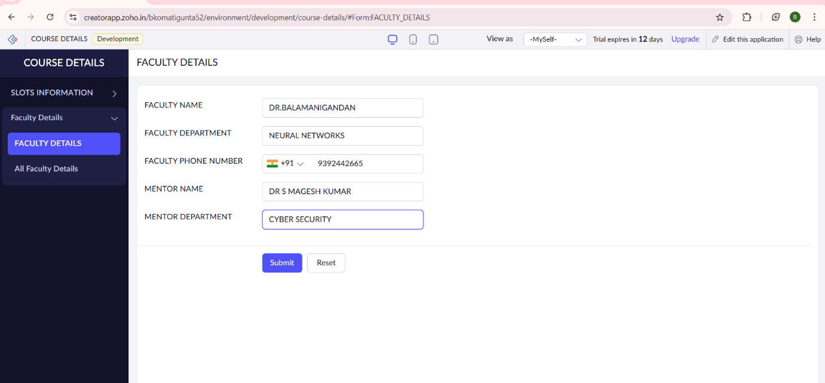

3.SLOT DETAILS

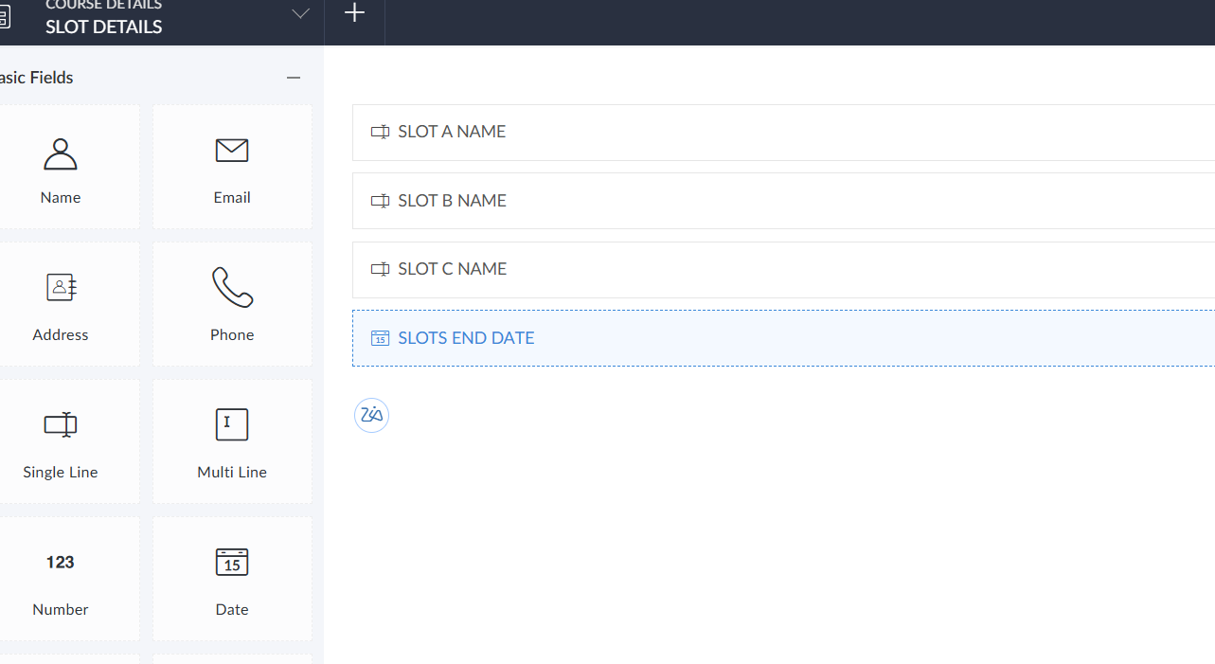

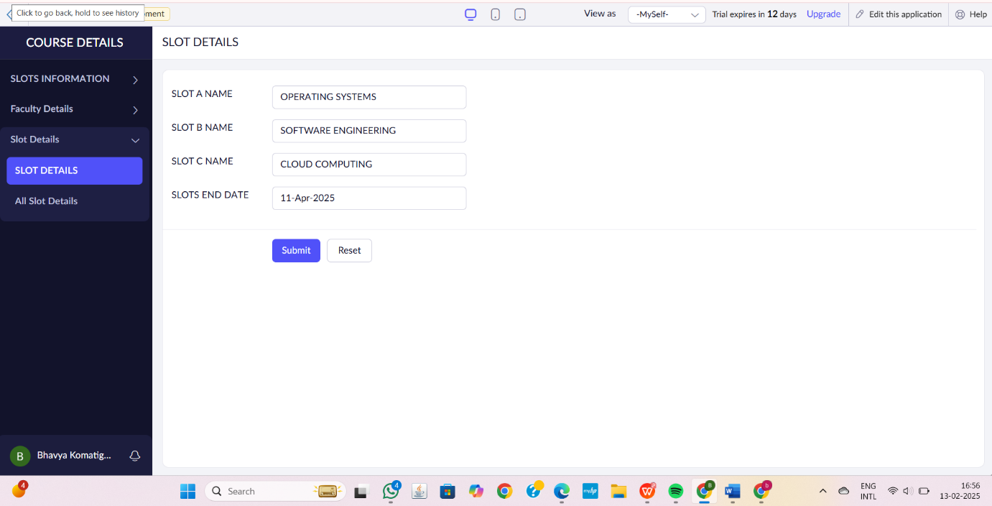

**STEP6:**THE SOFTWARE HAS BEEN CREATED.

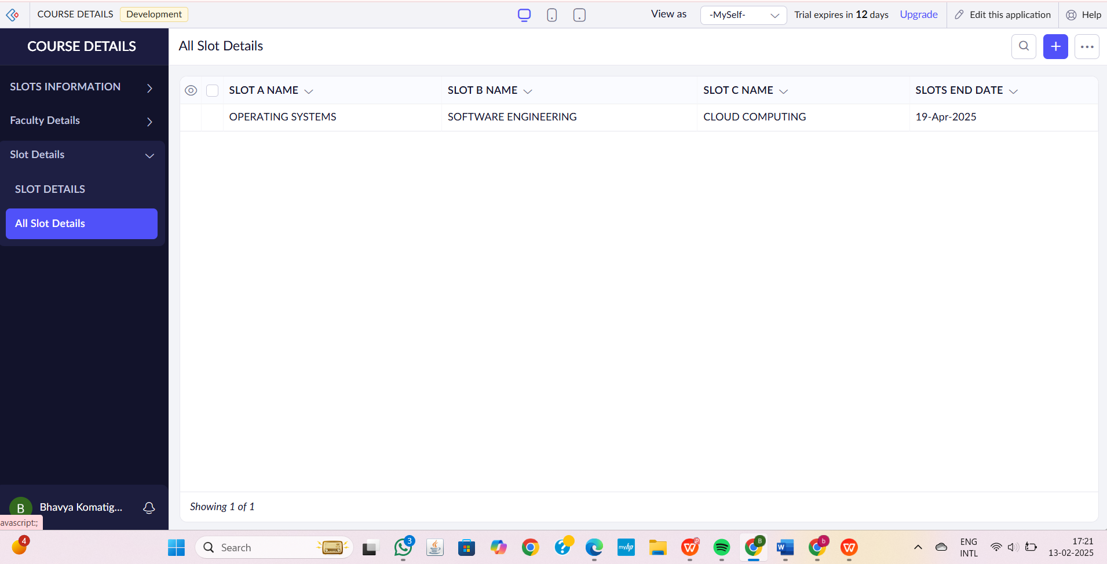

**EXP 2: Create a simple cloud software application for Flight Reservation System using any Cloud Service Provider to demonstrate SaaS.**

**DATE:13-02-25**

**AIM**:  The aim of the **Flight Reservation System** is to provide a cloud-based platform for users to search, book, and manage flights easily.

**PROCEDURE:**

**STEP1:**GO TO ZOHOCREATOR.COM AND LOGIN TO YOUR ACCOUNT

**STEP2:**CLICK CREATE NEW APPLICATION AND CREATE FROM SCRATCH

**STEP3:** ENTER APPLICATION NAME AND CREATE APPLICATION

**STEP4:**CLICK ON CREATE NEW FORM AND NAME THE FORM

**STEP5:**ENTER THE DETAILS

**STEP6:**THE SOFTWARE HAS BEEN CREATED.

**STEP1:**GO TO ZOHOCREATOR.COM AND LOGIN TO YOUR ACCOUNT



**STEP2:**CLICK CREATE NEW APPLICATION AND CREATE FROM SCRATCH

**STEP3:** ENTER APPLICATION NAME AND CREATE APPLICATION





**STEP4:**CLICK ON CREATE NEW FORM AND NAME THE FORM





1.FLIGHT INFORMATION AND ITS DETAILS

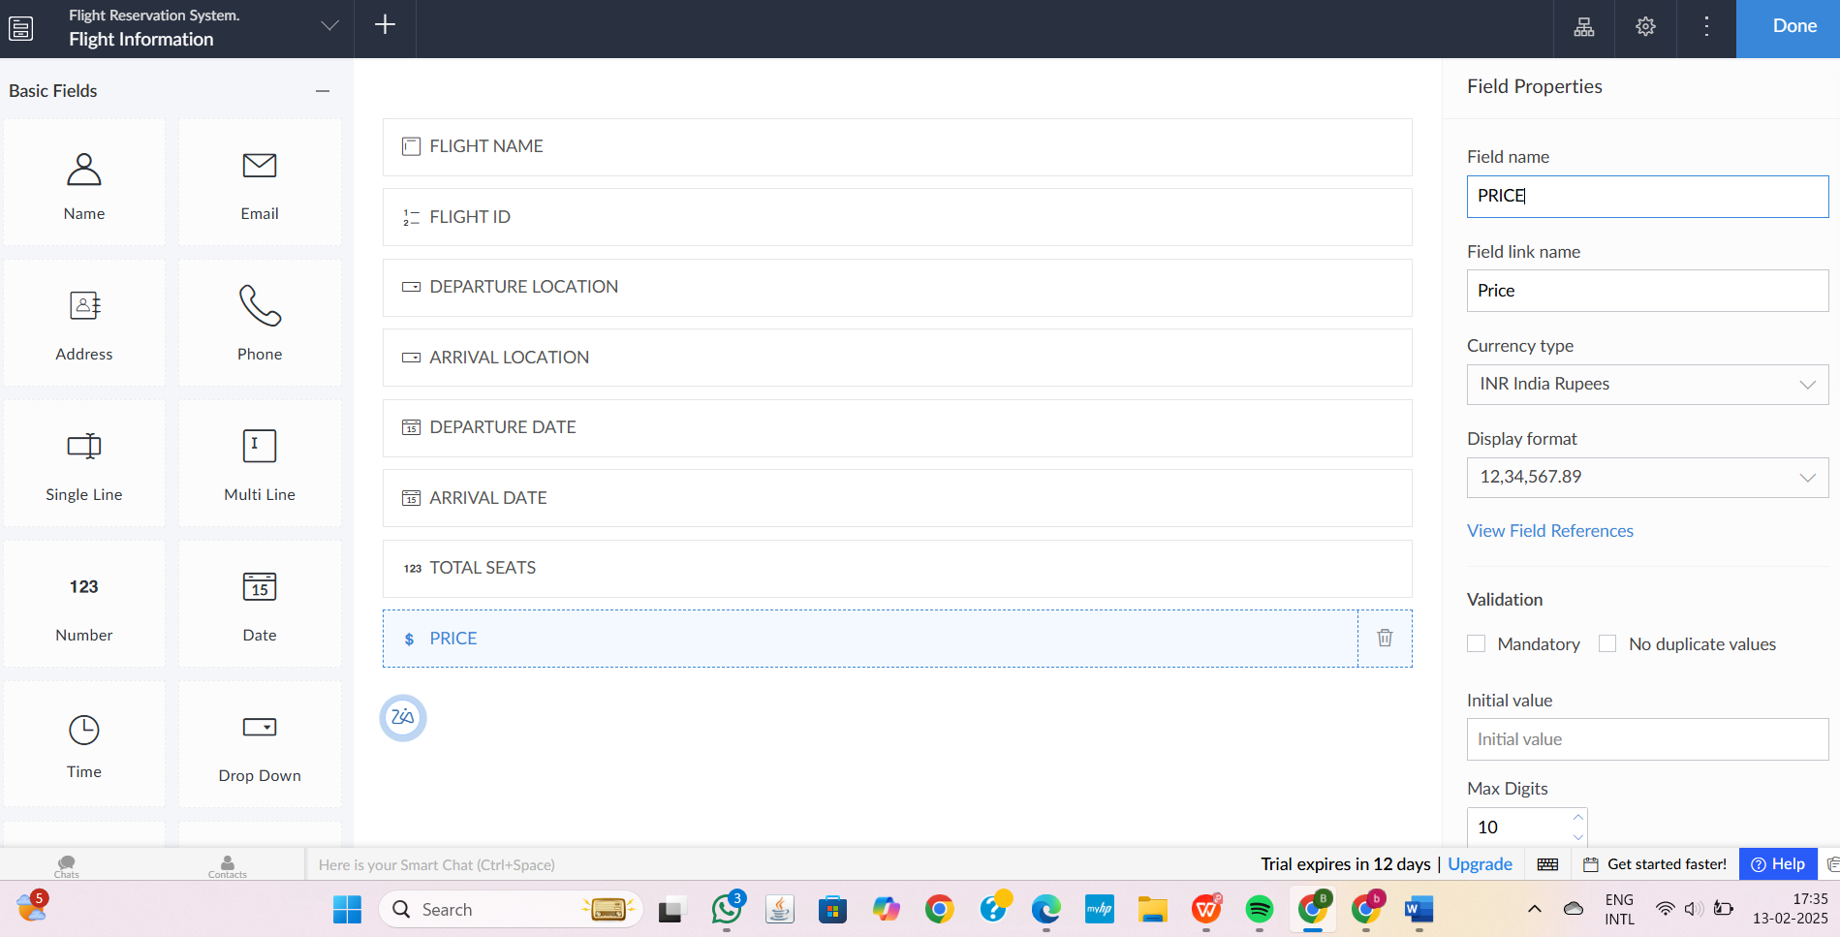

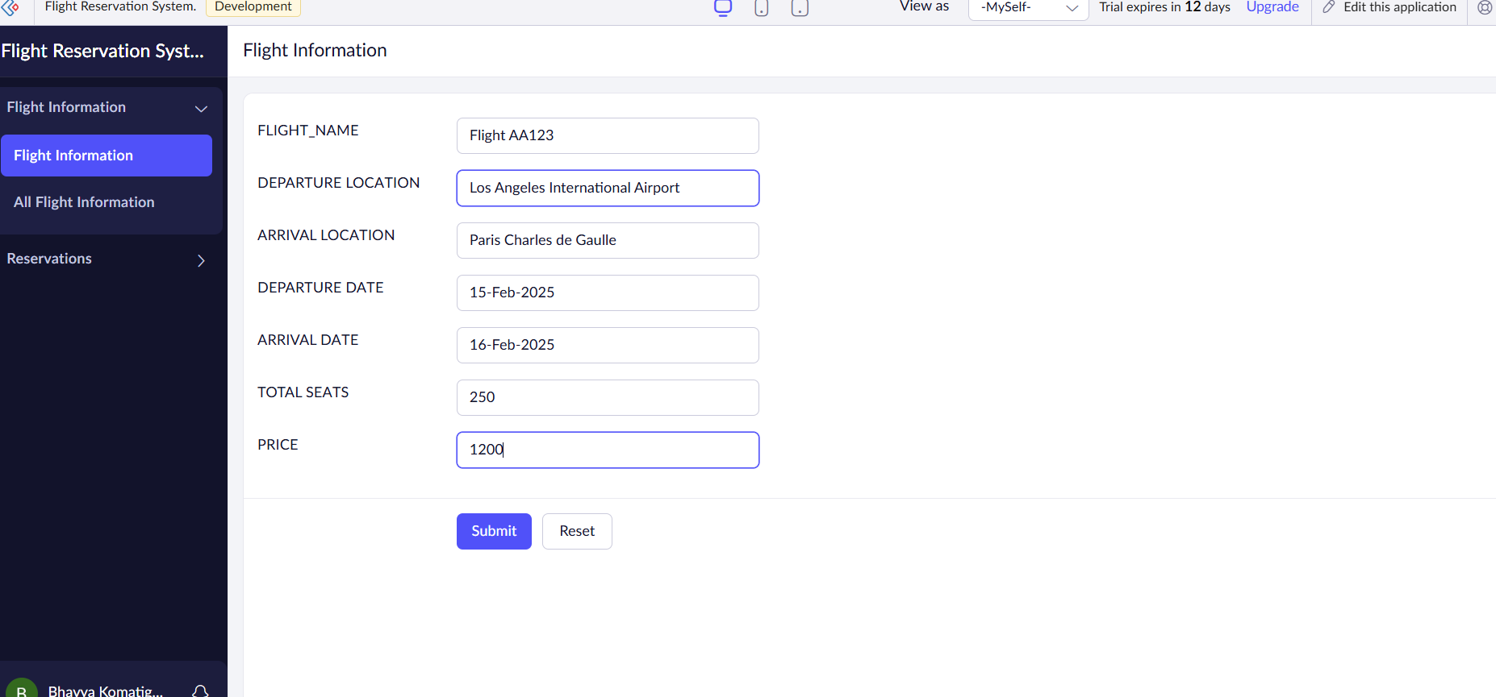

2.RESERVATION DETAILS

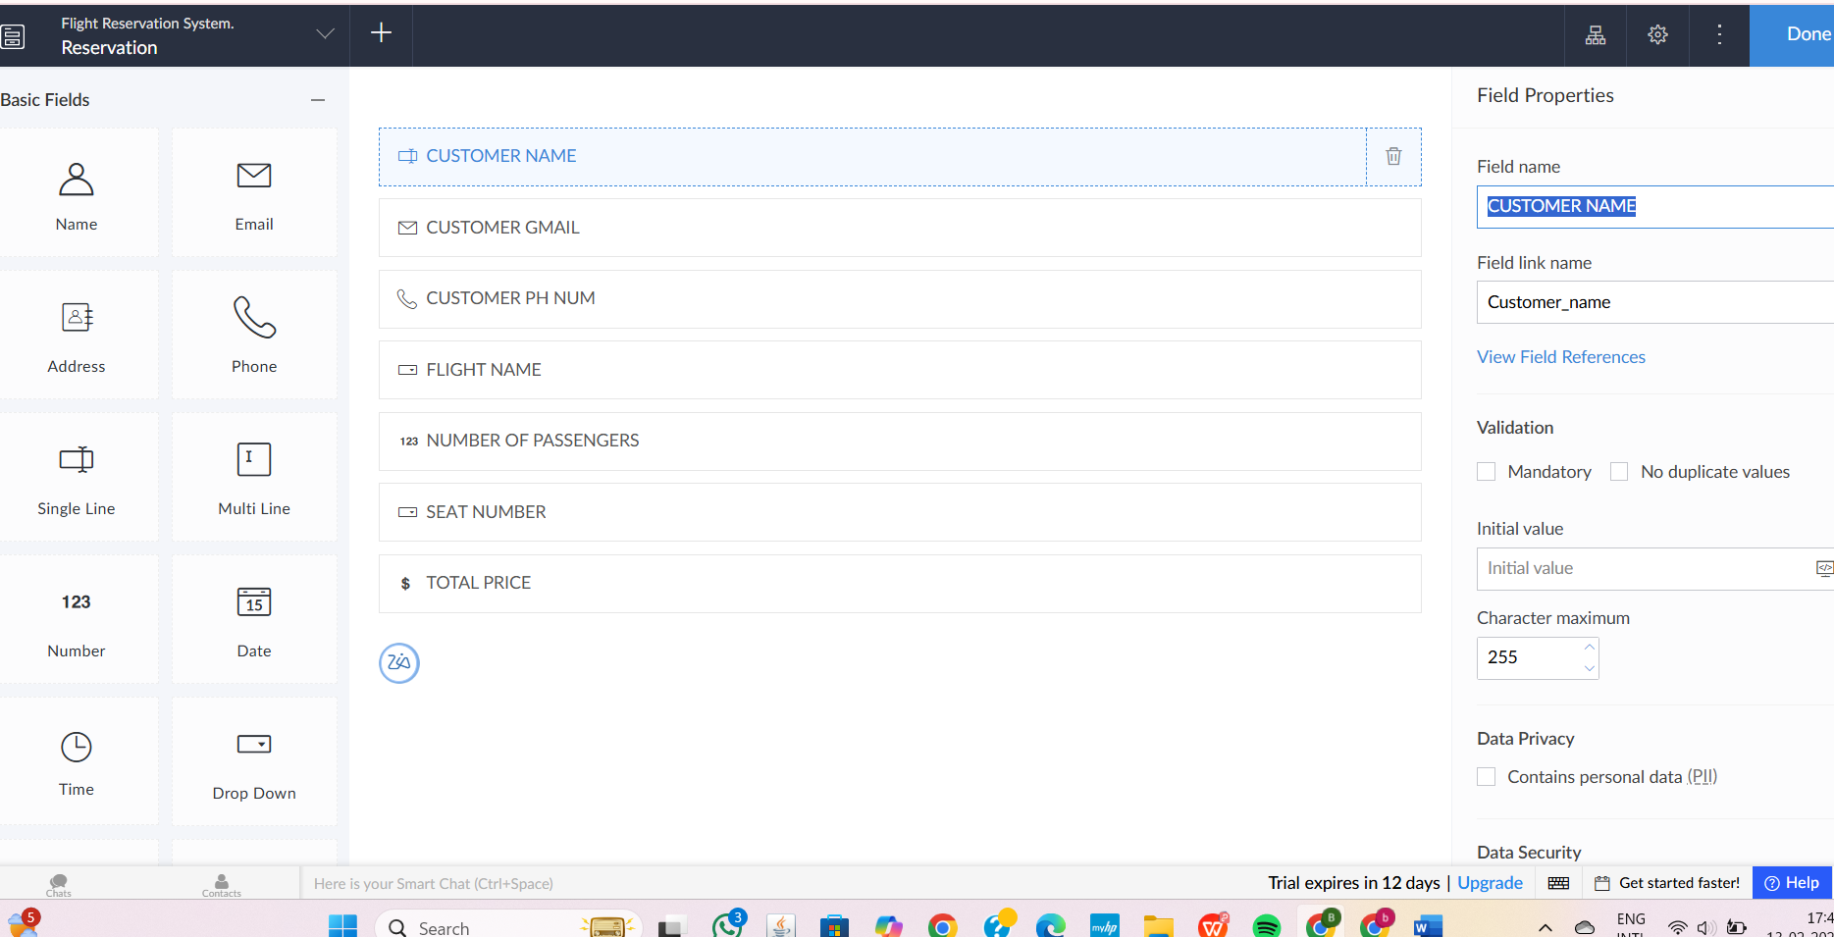

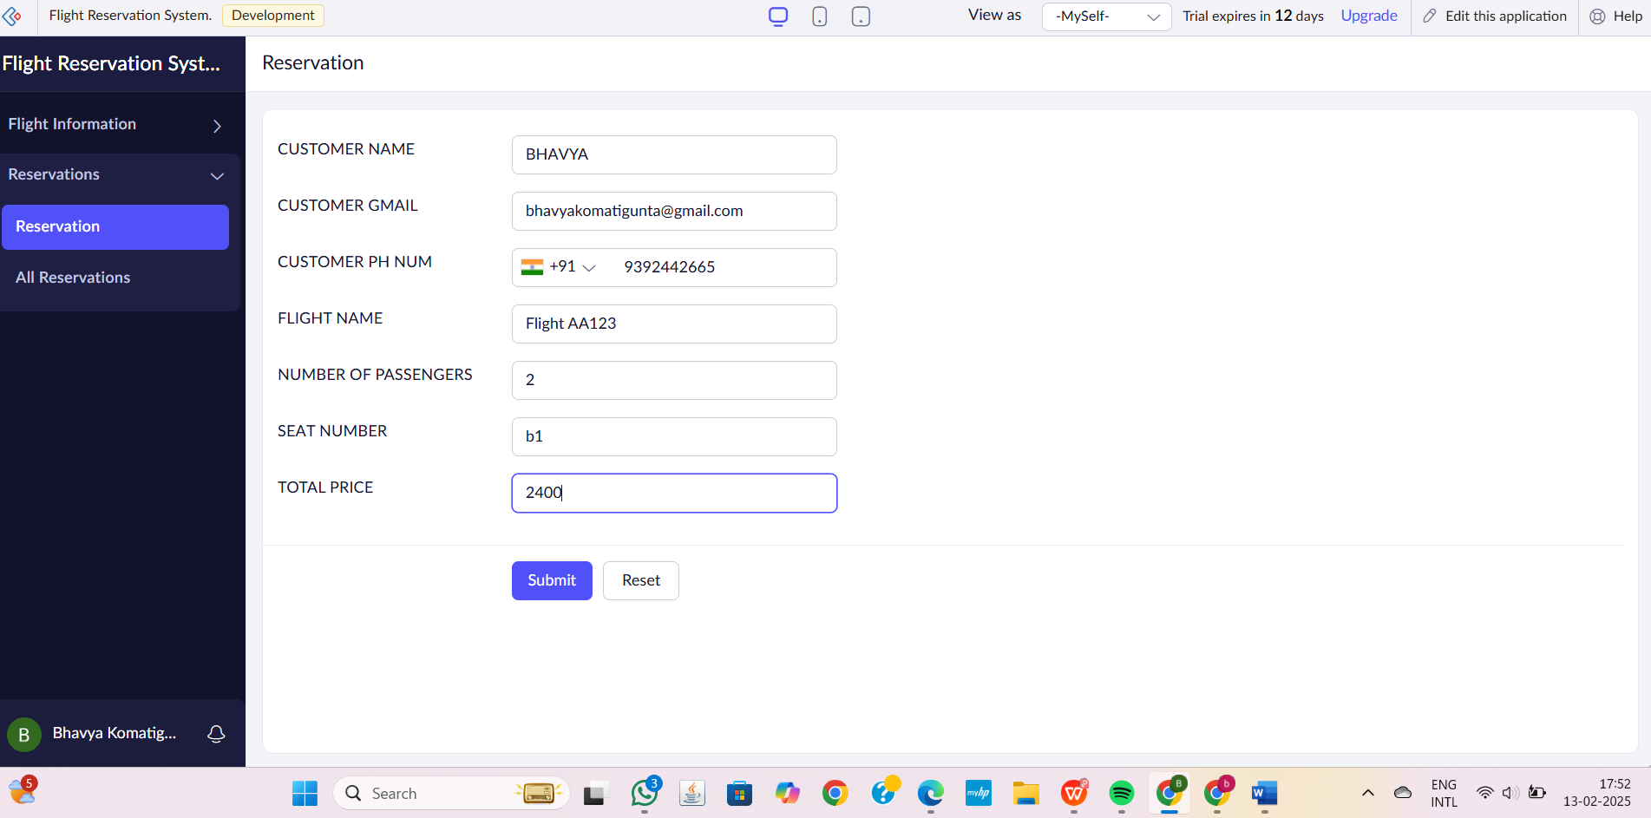

3.PAYMENT DETAILS

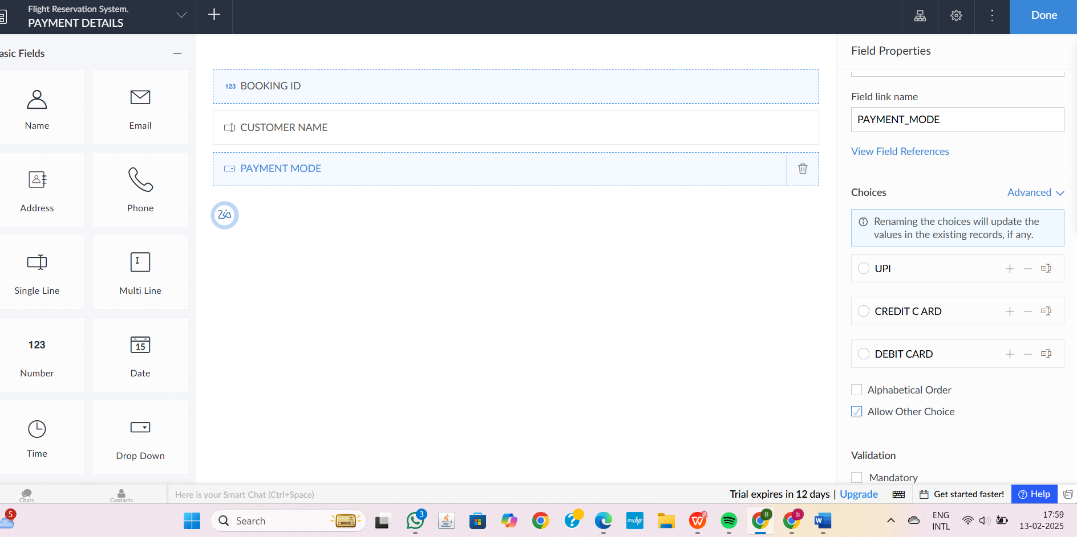

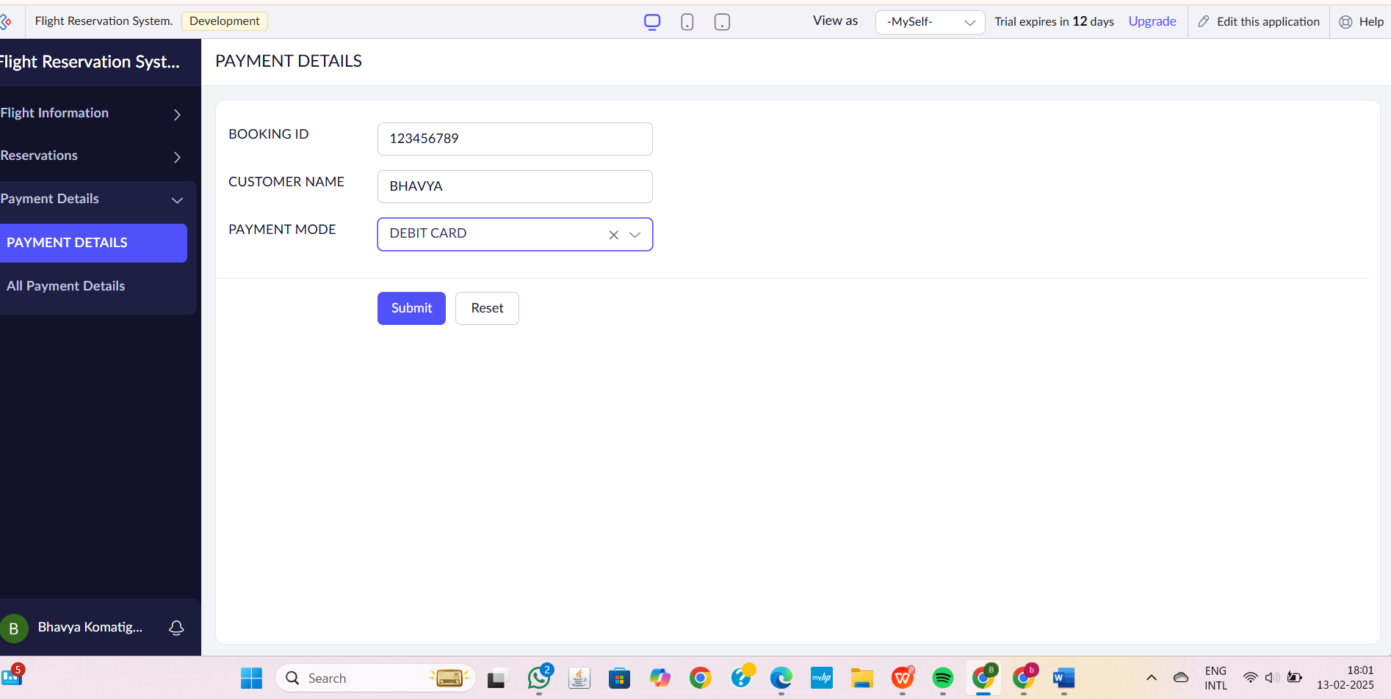

**STEP6:**THE SOFTWARE HAS BEEN CREATED.

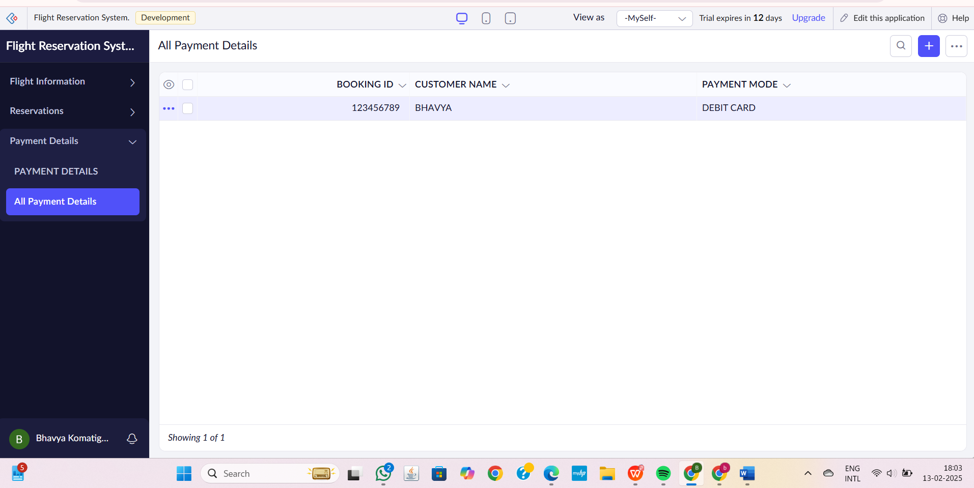

**EXP 3: . Create a simple cloud software application for Property Buying & Rental process (In Chennai city) using any Cloud Service Provider to demonstrate SaaS.**

**DATE:13-02-25**

**AIM**: The aim of the **Property Buying & Rental System** is to provide a cloud-based platform for users to easily search, buy, and rent properties in Chennai. It simplifies property management for owners and agents while ensuring real-time updates and accessibility.

**PROCEDURE:**

**STEP1:**GO TO ZOHOCREATOR.COM AND LOGIN TO YOUR ACCOUNT

**STEP2:**CLICK CREATE NEW APPLICATION AND CREATE FROM SCRATCH

**STEP3:** ENTER APPLICATION NAME AND CREATE APPLICATION

**STEP4:**CLICK ON CREATE NEW FORM AND NAME THE FORM

**STEP5:**ENTER THE DETAILS

**STEP6:**THE SOFTWARE HAS BEEN CREATED.

**STEP1:**GO TO ZOHOCREATOR.COM AND LOGIN TO YOUR ACCOUNT



**STEP2:**CLICK CREATE NEW APPLICATION AND CREATE FROM SCRATCH

**STEP3:** ENTER APPLICATION NAME AND CREATE APPLICATION





**STEP4:**CLICK ON CREATE NEW FORM AND NAME THE FORM





1.PROPERTY INFORMATION AND ITS DETAILS

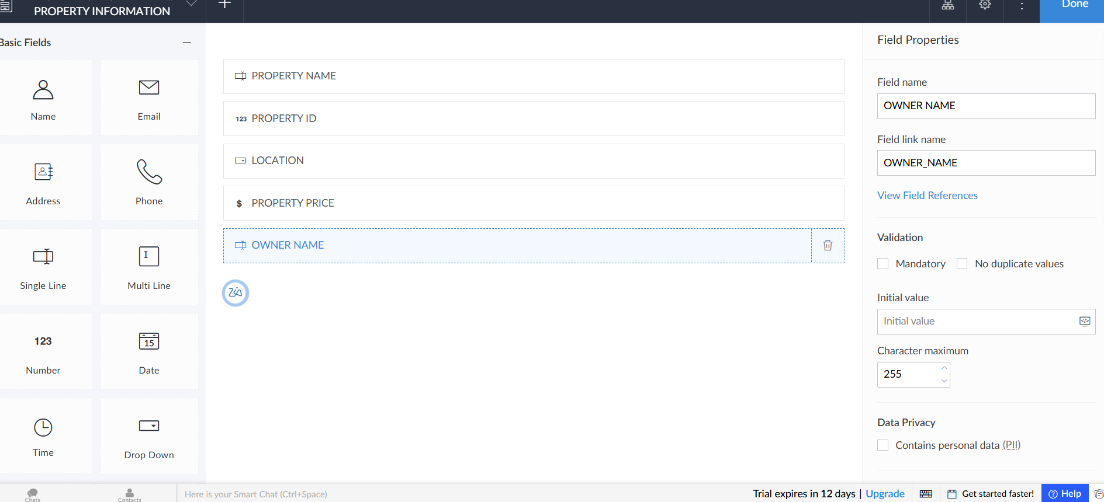

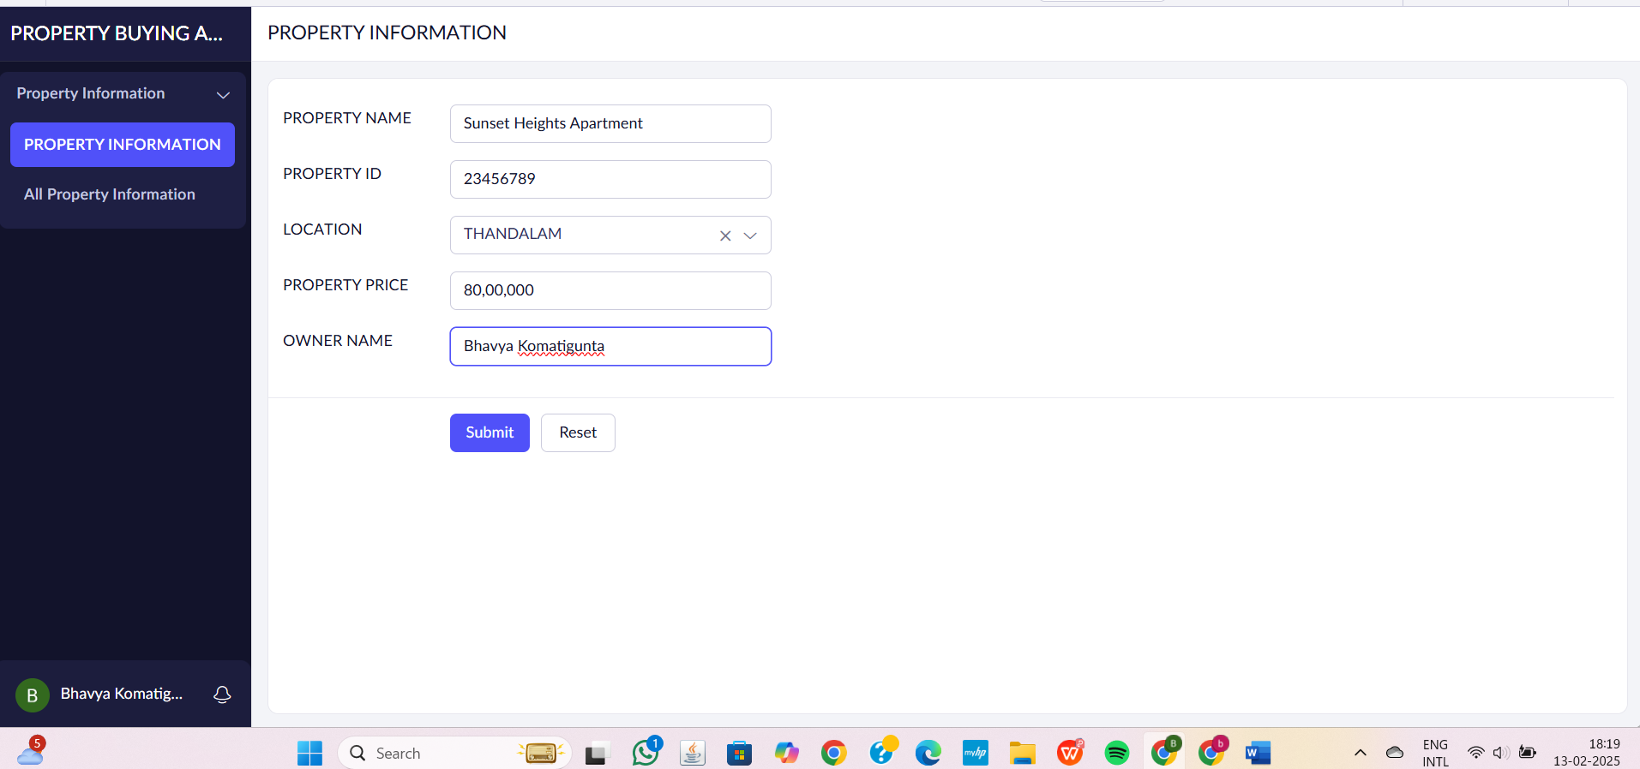

2.USER DETAILS

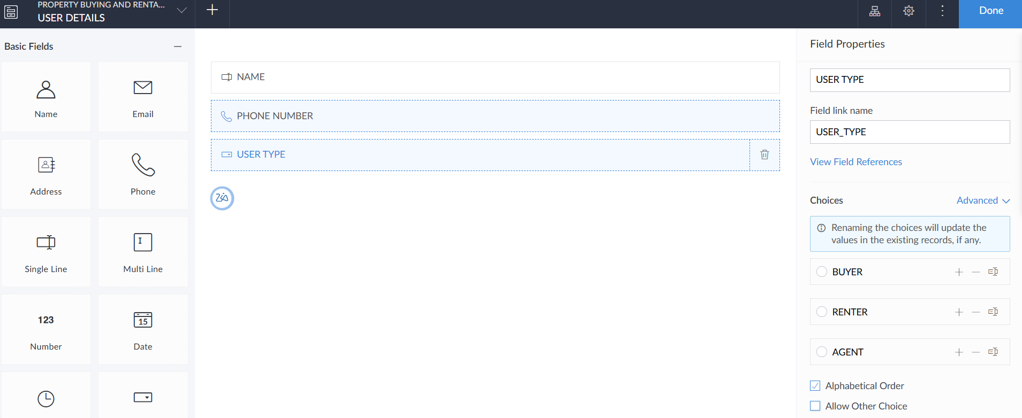

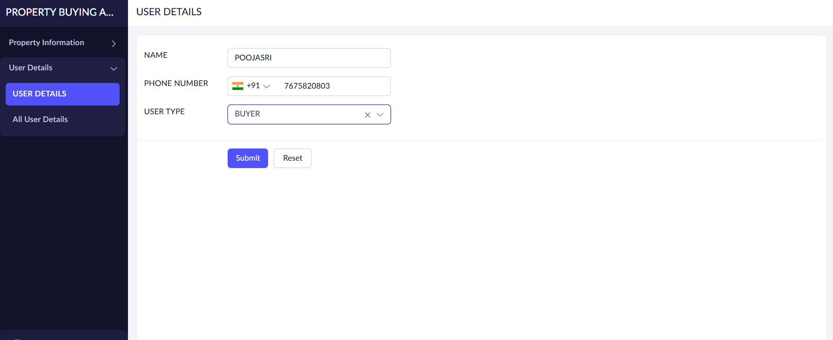

3.TRANSACTION DETAILS

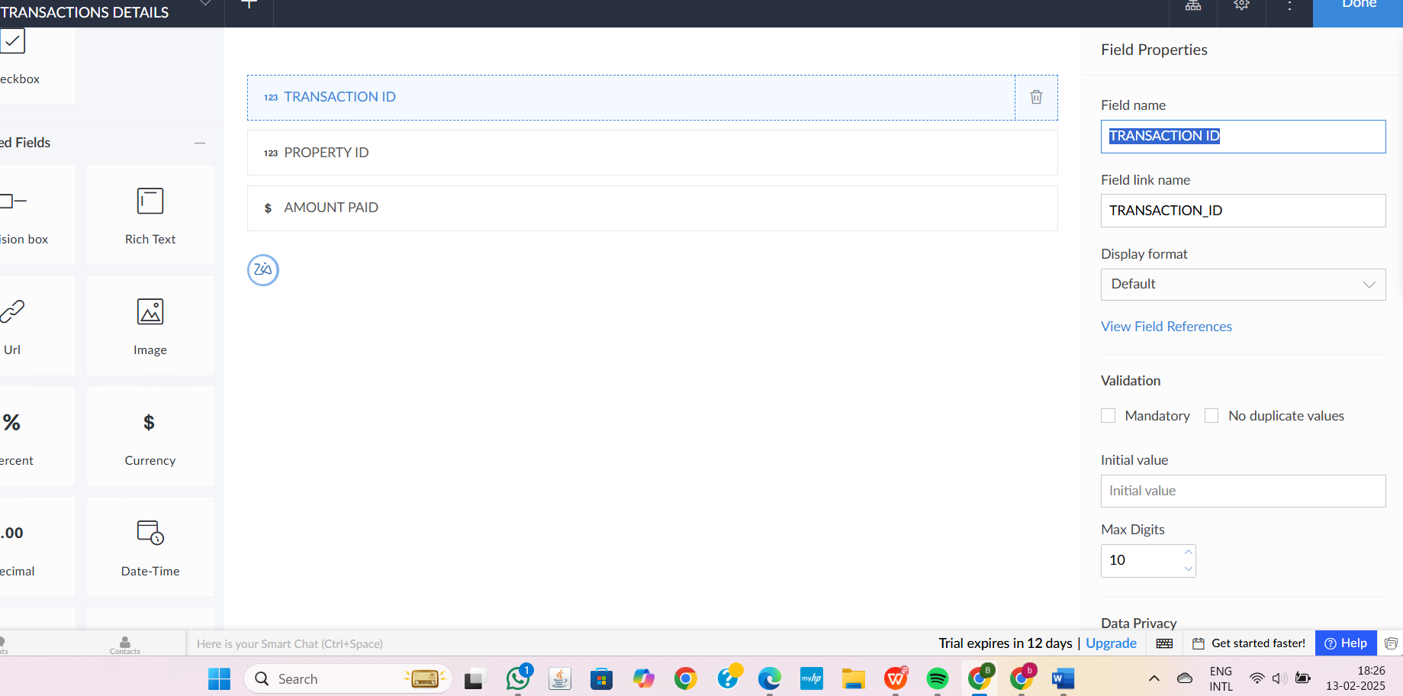

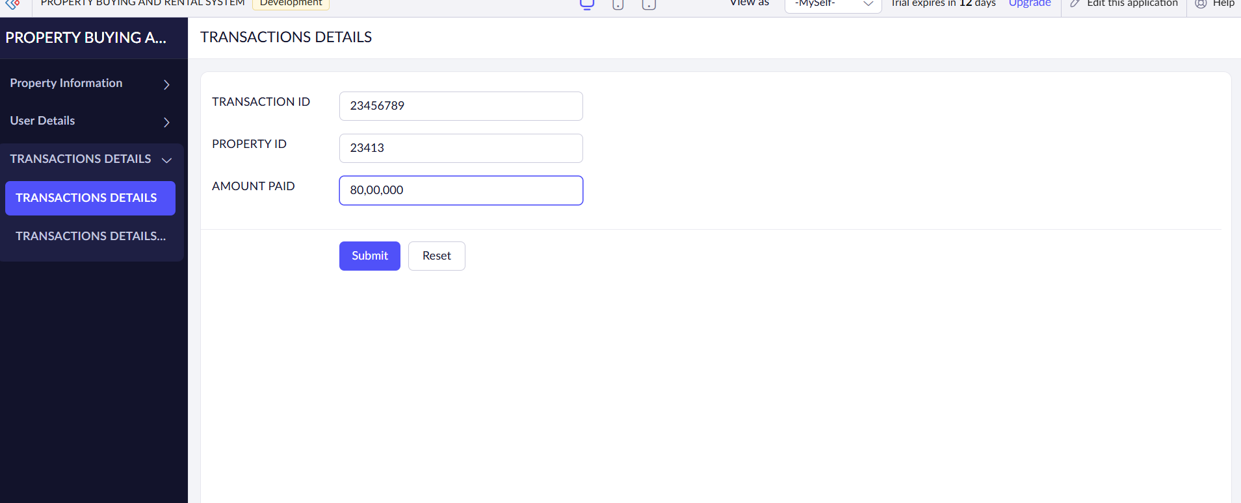

**STEP6:**THE SOFTWARE HAS BEEN CREATED.

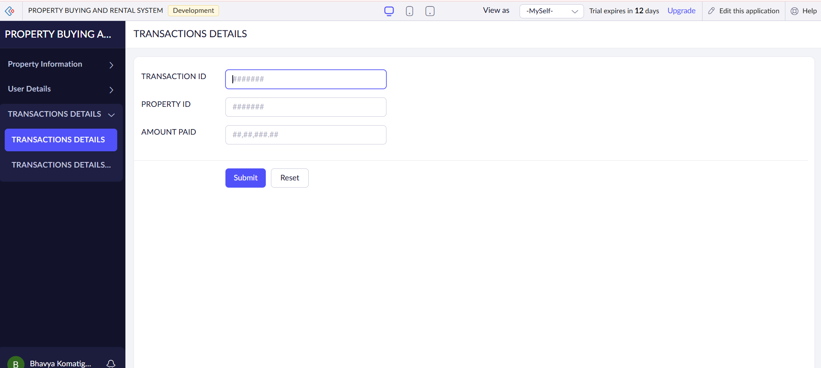

**EXP 4: Create a simple cloud software application for Car Booking Reservation System using any Cloud Service Provider to demonstrate SaaS.**

**DATE:14-02-25**

**AIM**: The aim of the Car Booking Reservation System SaaS is to provide a scalable, user-friendly platform for customers to book rental cars online while enabling businesses to efficiently manage reservations and car fleet availability.

**PROCEDURE:**

**STEP1:**GO TO ZOHOCREATOR.COM AND LOGIN TO YOUR ACCOUNT

**STEP2:**CLICK CREATE NEW APPLICATION AND CREATE FROM SCRATCH

**STEP3:** ENTER APPLICATION NAME AND CREATE APPLICATION

**STEP4:**CLICK ON CREATE NEW FORM AND NAME THE FORM

**STEP5:**ENTER THE DETAILS

**STEP6:**THE SOFTWARE HAS BEEN CREATED.

**STEP1:**GO TO ZOHOCREATOR.COM AND LOGIN TO YOUR ACCOUNT



**STEP2:**CLICK CREATE NEW APPLICATION AND CREATE FROM SCRATCH

**STEP3:** ENTER APPLICATION NAME AND CREATE APPLICATION





**STEP4:**CLICK ON CREATE NEW FORM AND NAME THE FORM





1.CUSTOMER INFORMATION AND ITS DETAILS

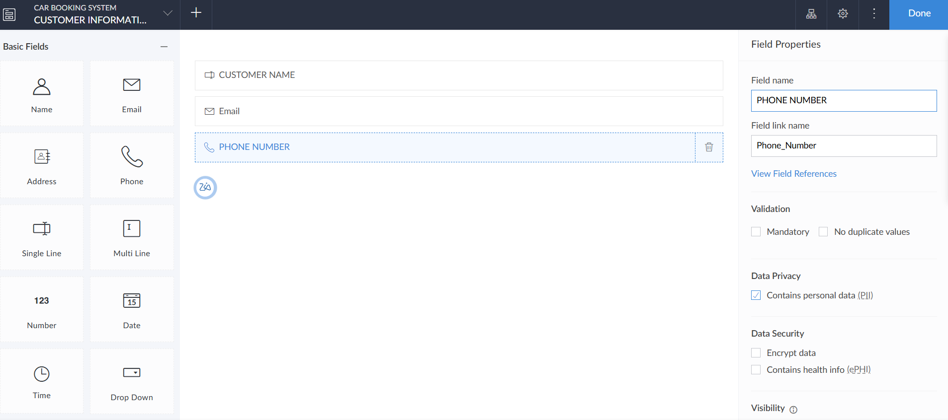

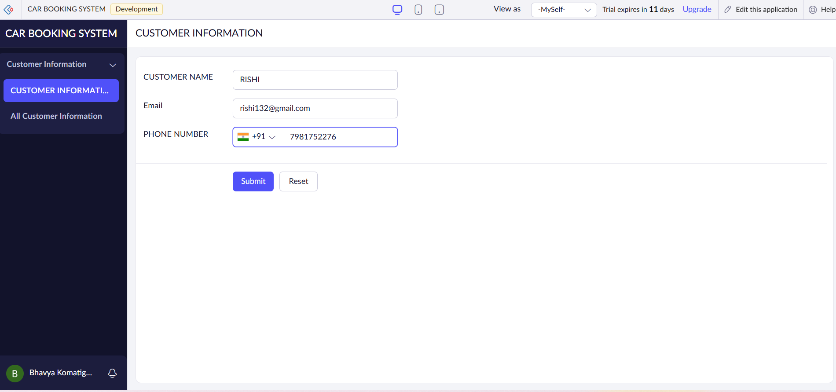

2.BOOKING DETAILS

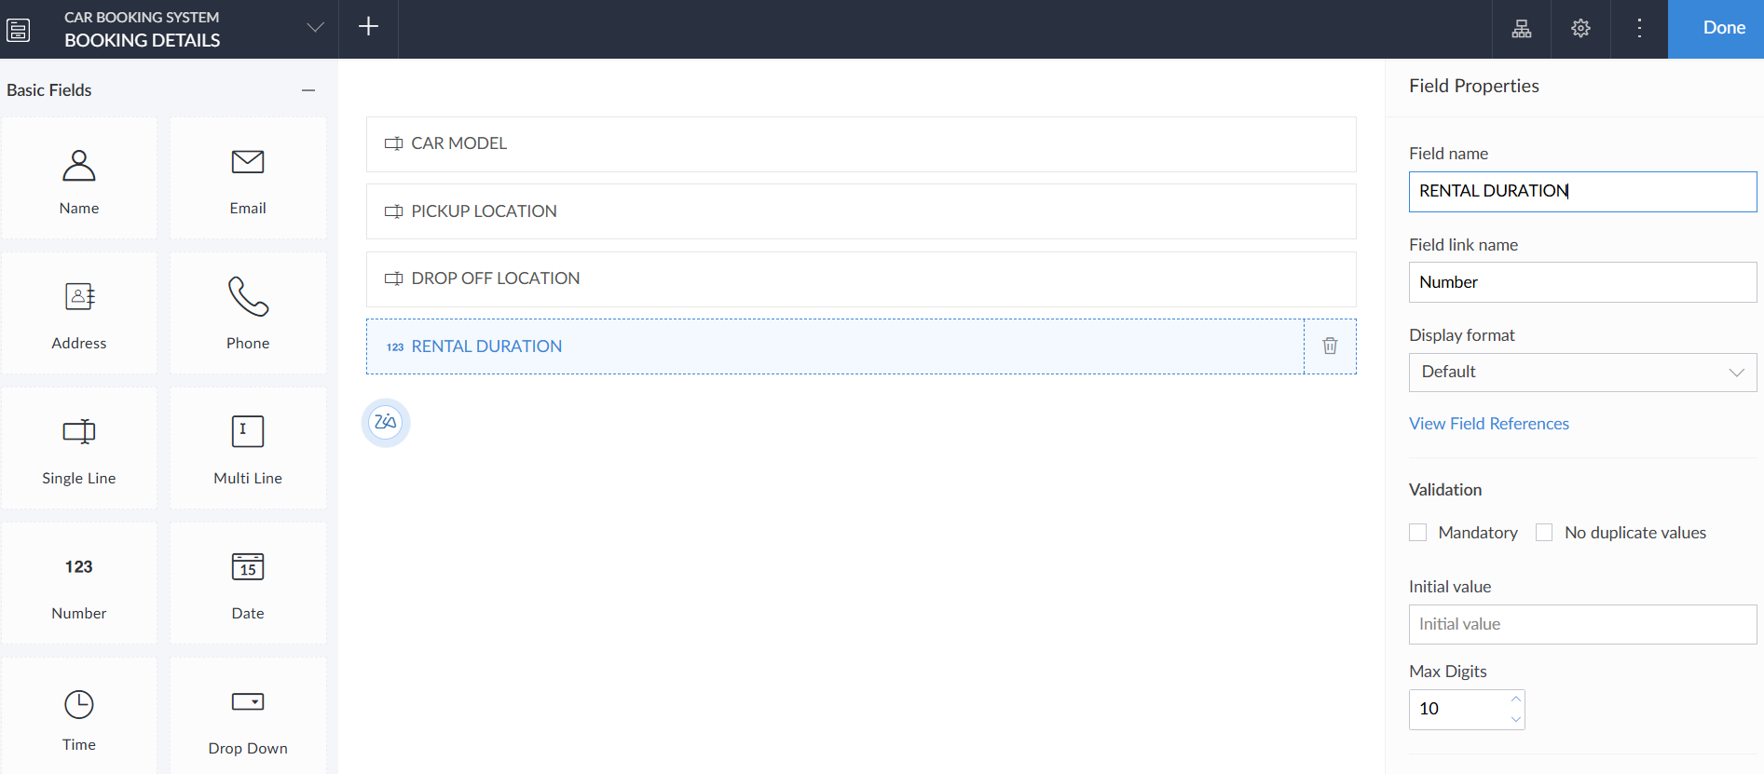

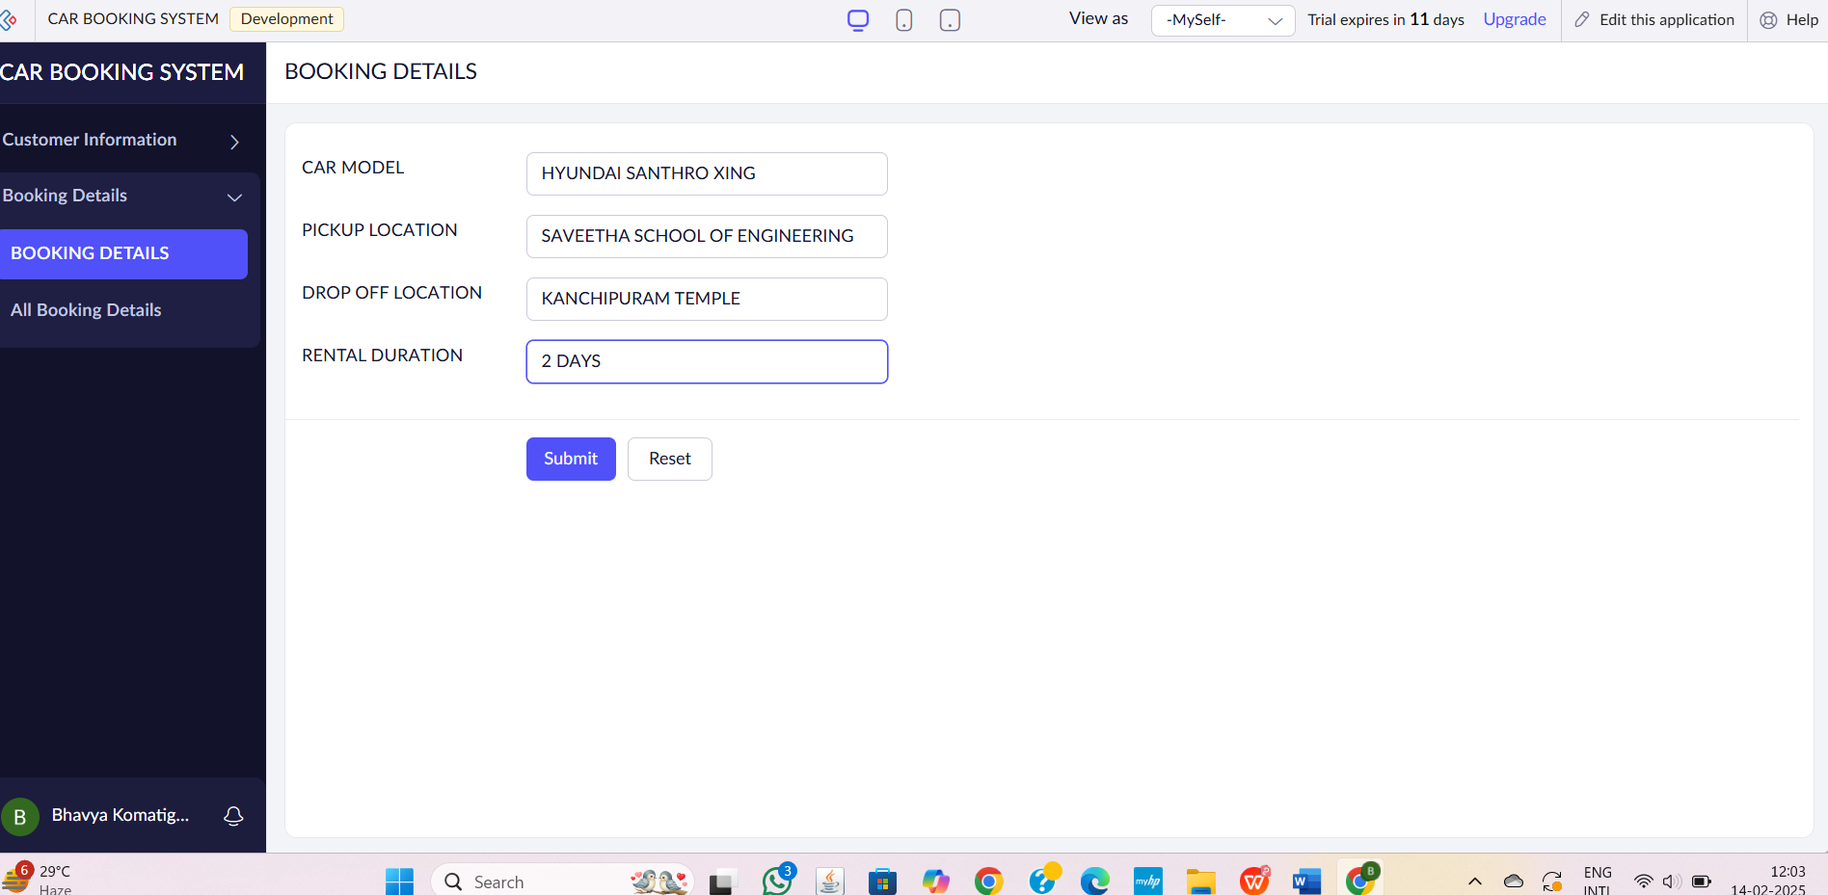

3.PAYMENT INFORMATION

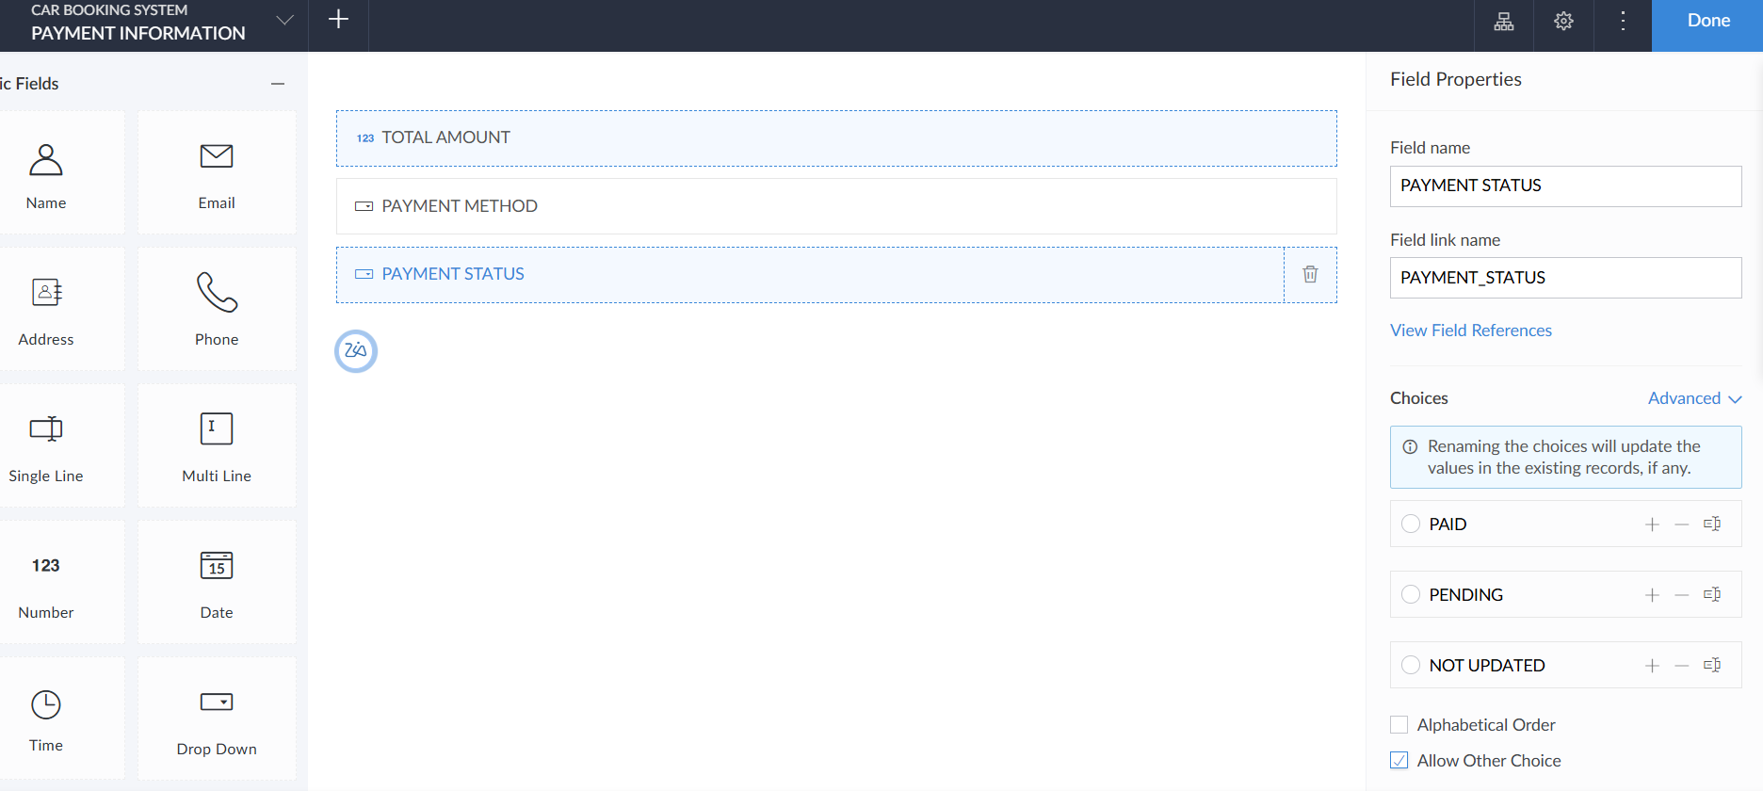

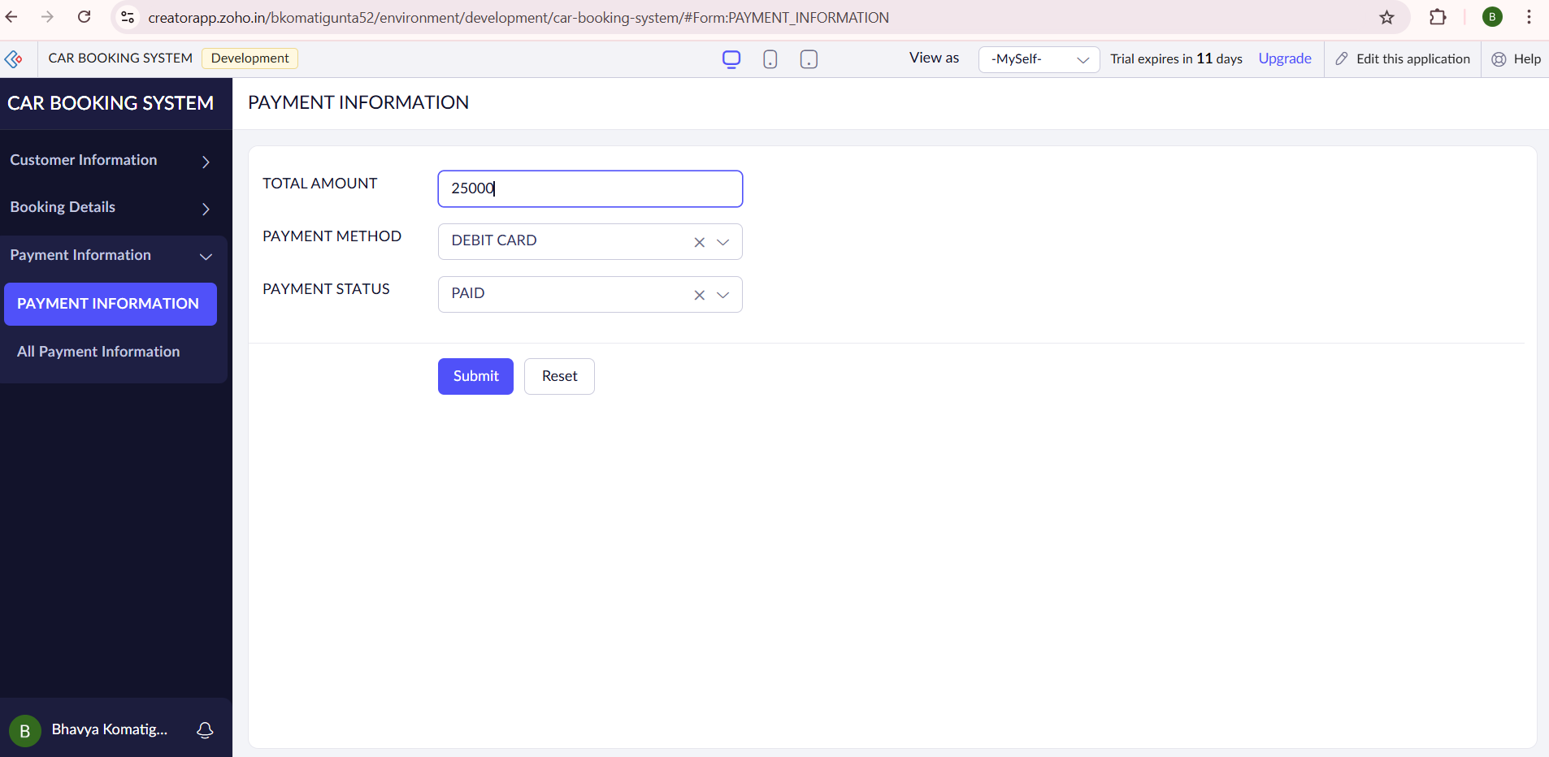

**STEP6:**THE SOFTWARE HAS BEEN CREATED.

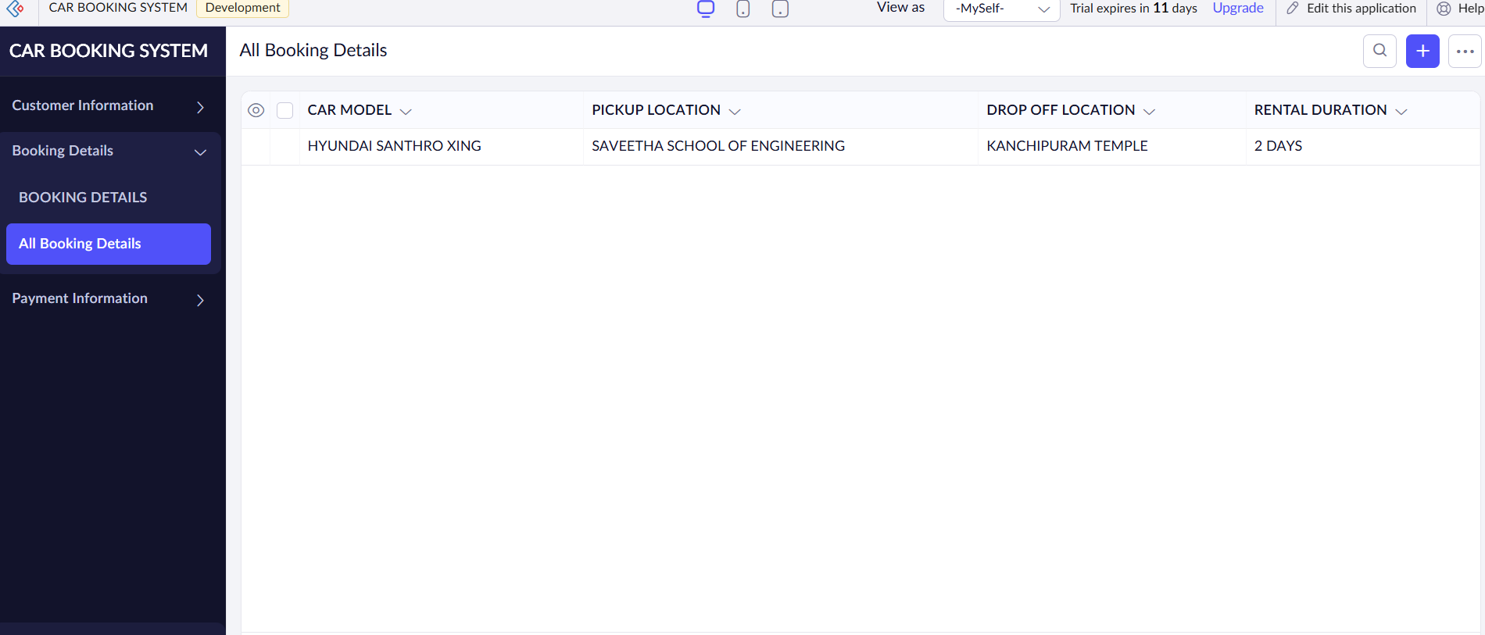

**EXP 5: Create a simple cloud software application for Library book reservation system for SIMATS library using any Cloud Service Provider to demonstrate SaaS.**

**DATE:14-02-25**

**AIM**:

**PROCEDURE:**

**STEP1:**GO TO ZOHOCREATOR.COM AND LOGIN TO YOUR ACCOUNT

**STEP2:**CLICK CREATE NEW APPLICATION AND CREATE FROM SCRATCH

**STEP3:** ENTER APPLICATION NAME AND CREATE APPLICATION

**STEP4:**CLICK ON CREATE NEW FORM AND NAME THE FORM

**STEP5:**ENTER THE DETAILS

**STEP6:**THE SOFTWARE HAS BEEN CREATED.

**STEP1:**GO TO ZOHOCREATOR.COM AND LOGIN TO YOUR ACCOUNT



**STEP2:**CLICK CREATE NEW APPLICATION AND CREATE FROM SCRATCH

**STEP3:** ENTER APPLICATION NAME AND CREATE APPLICATION





**STEP4:**CLICK ON CREATE NEW FORM AND NAME THE FORM





1.STUDENT DETAILS

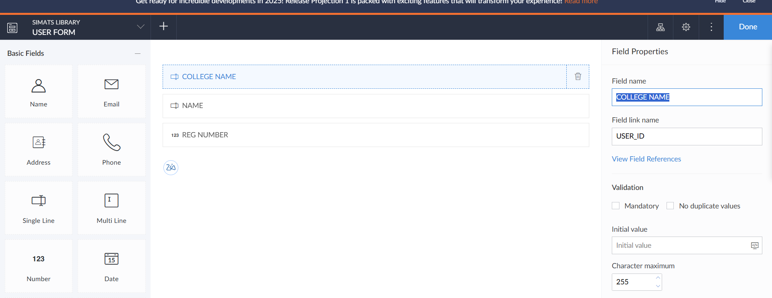

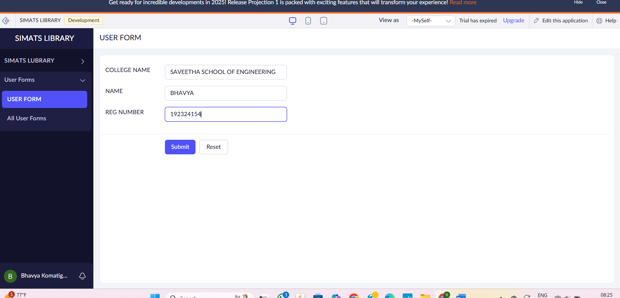

2.BOOK DETAILS

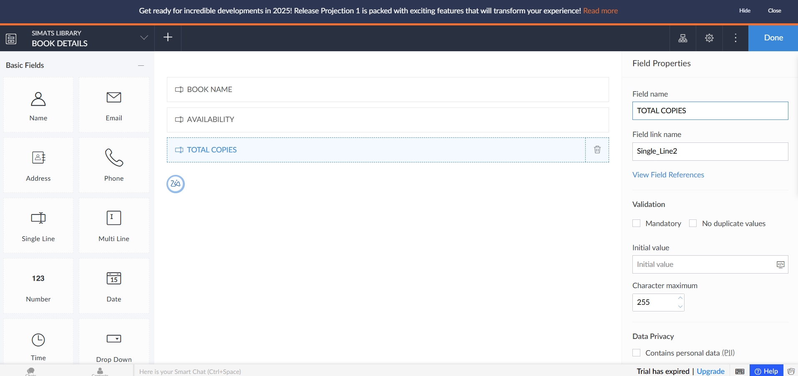

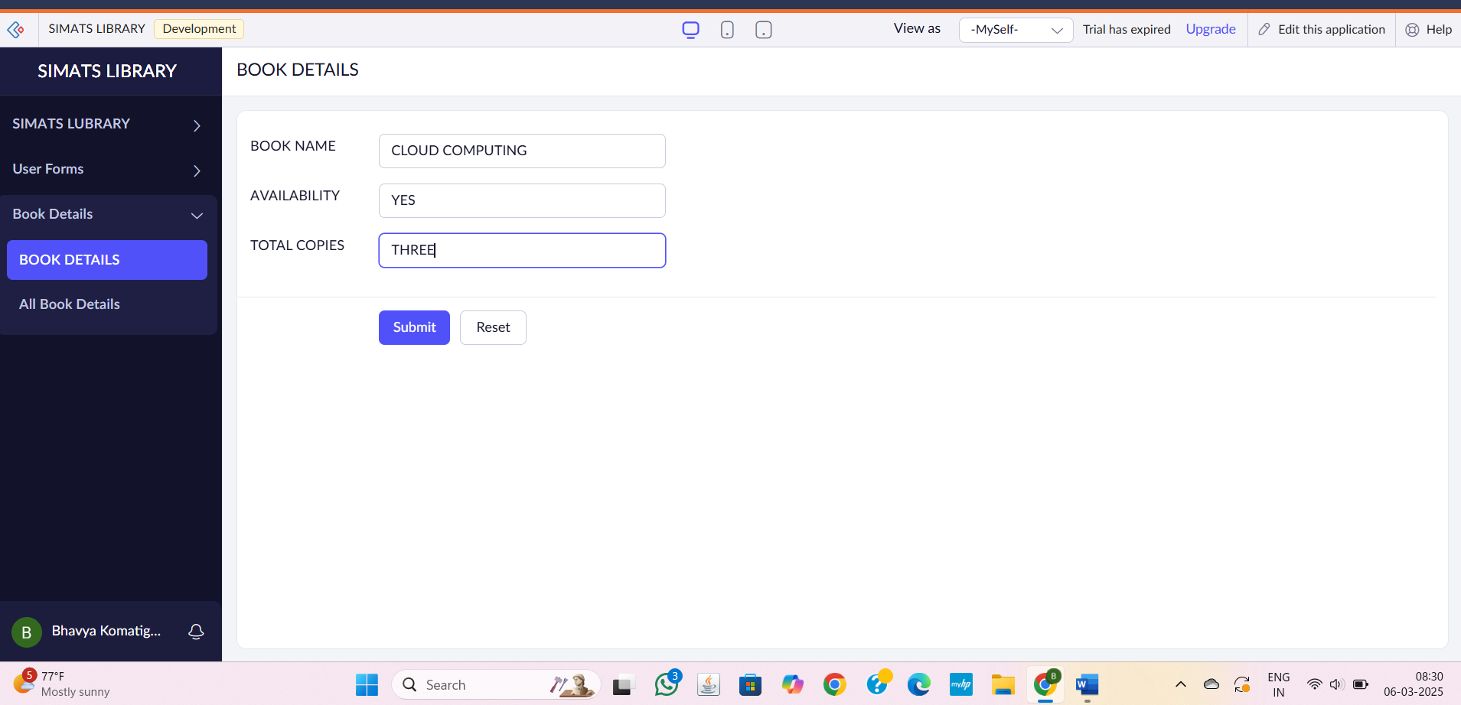

3.RESERVATION OF BOOK DETAILS

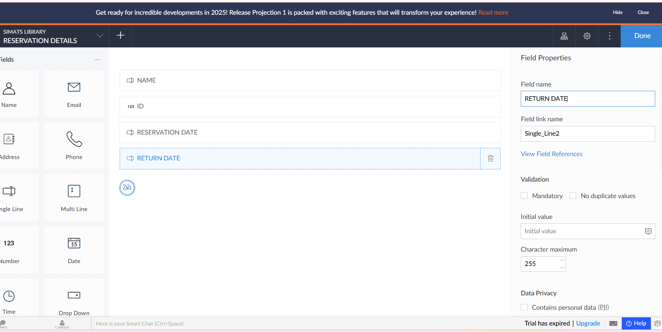

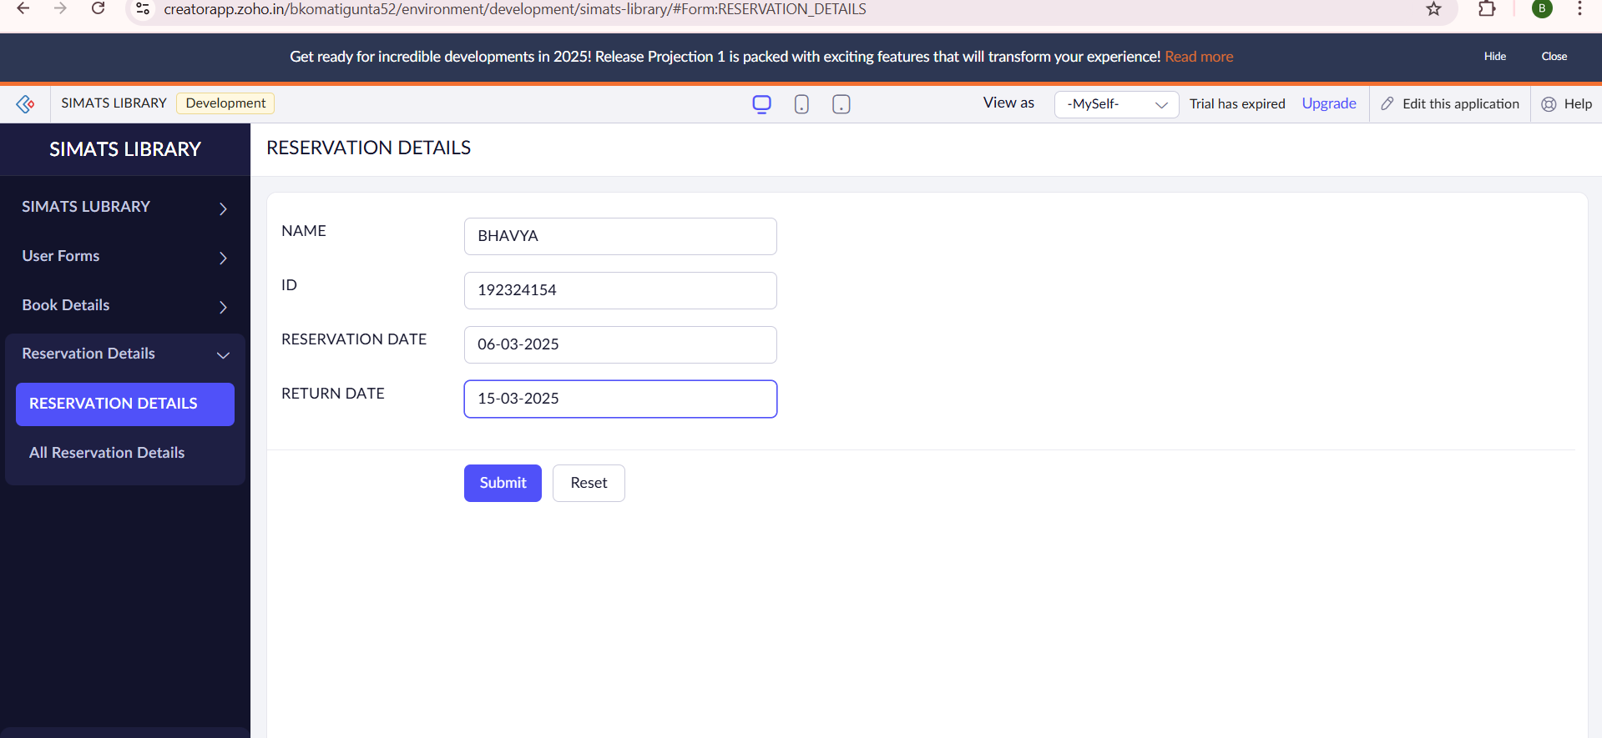

**STEP6:**THE SOFTWARE HAS BEEN CREATED.

